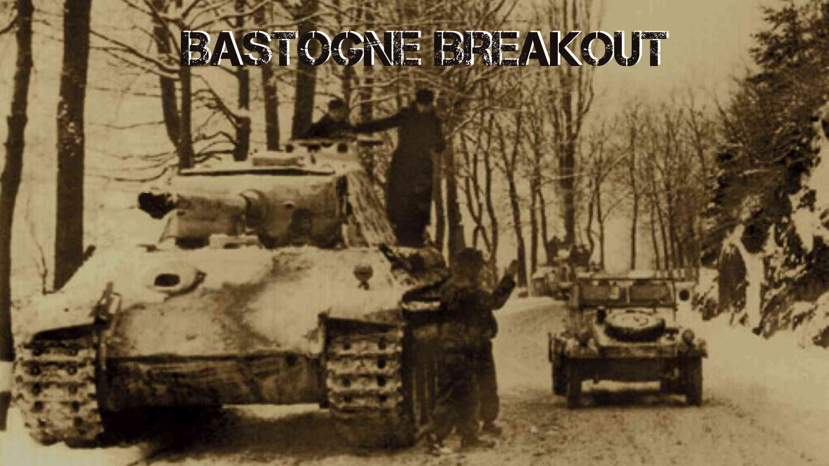

1. IntroductIon
2. 2.0 components
   1. Fourth Edition Rules
   2. Maps
   3. Charts,Tables, and Tracks
   4. Counters
3. 3.0 scenarIos
   1. General Course of a Game
   2. Setting Up
   3. Turns

3.4 Winning a Game

4.0 sequence of play

4.1 Turn Sequence

4.2 Night Turns

4.3 Rain Turns

5.0 movement

5.1 Movement Limitations

5.2 Effects of Terrain on Movement

5.3 Enemy Units and Zones of Control

5.4 Movement and Friendly Units

5.5 Exiting the Map

5.6 Entering the Map

6.0 combat

6.1 Which Units Attack and Defend

6.2 Calculating the Odds

6.3 Terrain Effects on Combat

6.4 Combat Results

6.5 Elimination and Exchange

6.6 Retreating After Combat

6.7 Advancing After Combat

# Introduction version 1.0

Bastogne Breakout is a computer simulation of the German winter offensive in 1944 called the Battle of the Bulge. Its focus is the south part of the battle over control of the road network around the Belgium city of Bastogne. This was crucial for the breakthrough of the German LVIII Panzer Corp on it route to Namur. The player may choose to control both the German and Allied forces. This is called Hot Seat mode. The player can also choose to control the German forces against the Allied forces which are controlled by the computer (AI). Currently the computer only plays the allied side.

# Player Control

* 1. **Windows and Macintosh Personal Computers**
* **Mouse Left Click** this is Selection process for most of the game. This includes Unit Selection, Hex Selection and Icon Selection. Also used to pan the map.
* **Mouse Hover** will display extra information relevant to what the mouse is hovering over. Also called tooltips.
* **Mouse Right Click** will bring the bottom unit in a stack of units to the top of the display.
* **Mouse Wheel** to zoom in and out of the map.
* **Keyboard** provides shortcuts for scrolling and zooming the map. It also provides shortcuts for information.
* **Cancel** a number of functions can be cancelled by Left clicking the mouse or selecting an area not related to the function such as another part of the map.
  1. **Android and IOS Devices TBA**

# Components

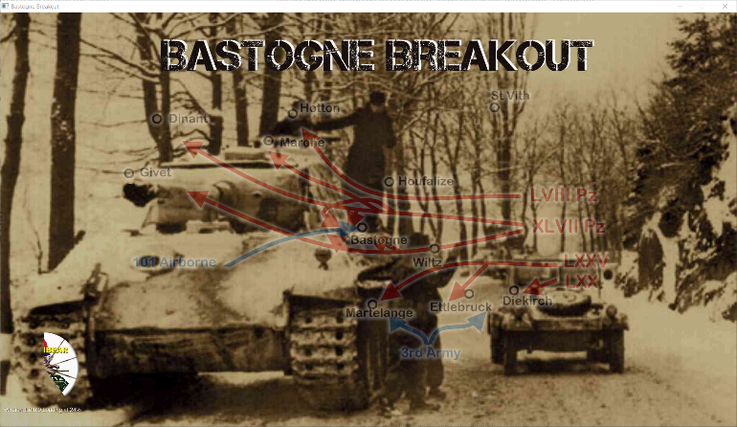**3.1** **SplashScreen**

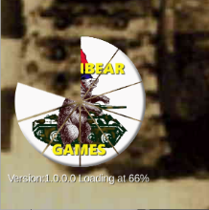When the program is started the initial display will show a picture of units of Panzer Lehr in the Ardennes. Overlaid is the title, a map of 5th Panzer Armies objectives.

The bottom left shows the percentage of game loaded, version of the game and the BruinBear logo reflecting the percentage of the game loaded. The music is a harmonica version of Lili Marlene. After the game is loaded the Main Menu will appear.

**3.2** **Main Menu**

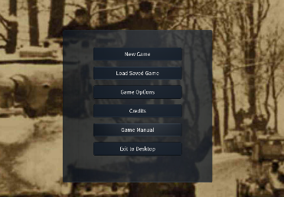

Select a game function:

* New Game
* Load Saved Game
* Game Options
* Credits
* Game Manual
* Exit to Desktop

Choosing New Game will display the Game Menu where the game is started.

**3.3** **Game Menu**

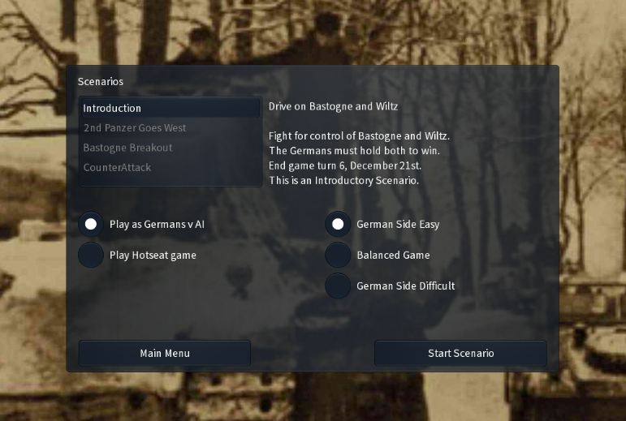

Select a Scenario to play is on the top. Currently there are 2 scenarios available.

* + - Bastogne Breakout,
    - 2Nd Panzer Goes West.
* Middle left area choose to play as Germans against AI or play Hotseat.
* Middle right area choose difficulty level for the game.
* Bottom Left button to return to Main Menu.
* Bottom Right start scenario chosen.

**3.4** **Load Saved Game**

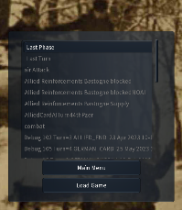Allows users to restart a previously saved game. Use the scroll button on the right with mouse wheel to find the game, select the game and then select the Load Game button.

The game will start where it was save previously

**3.5** **Game Options**

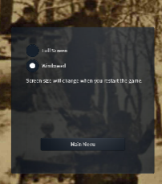

Sets the Screen to either windowed mode or full screen. Game will need to be restarted to take effect.

**3.6** **Map**

The game is played on a map which is a representation of the actual terrain around Bastogne and Wiltz in December 1944.

The map is overlaid with hexagonal grid to govern movement, combat and supply rules. Each hexagon is associated with a specific terrain type which effect movement, supply and combat.

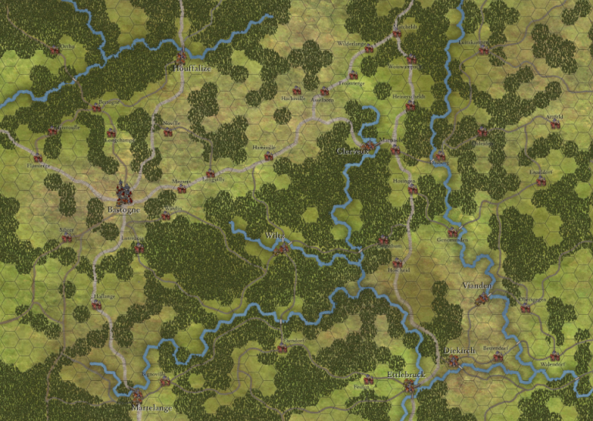

**Map Scale:** Each hex represents 1 mile or 1.6 kilometer from side to side.

The map can be scrolled either through keyboard arrow keys or left mouse click panning.

The map can be zoomed with “+” or “-“on the keyboard or the mouse wheel.

**3.7** **Counters**

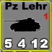 Playing pieces called Counters represent the actual units involved in the battles as well as informational markers. Each playing counter represents an actual unit involved in the battle. They represent battalions, regiments, brigades and Kampgruppe (ad hoc German units).

When a counter is selected it is highlighted with a yellow band around its perimeter.

* **Mechanized Units** have silhouette of tanks, armored troop carriers, self propelled artillery or towed artillery. Examples below are:

* + German Armored Kampfgruppe of Panther Tanks and SDK.KFZ.1 Half Tracks belonging to 2nd Panzer Division

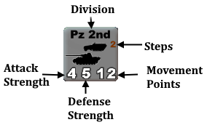

* + Allied 155 mm Towed Artillery, Limbered for movement.

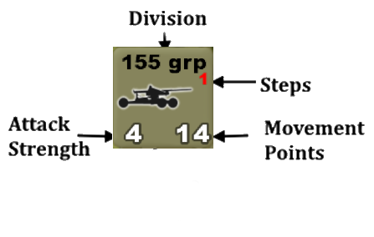

* + Artillery Unlimbered

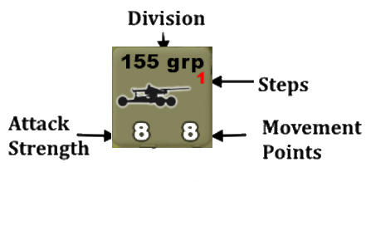

* **Infantry Units** have silhouettes of soldiers. Example
  + German Infantry regiment of the Volksgrenadier 26th Division

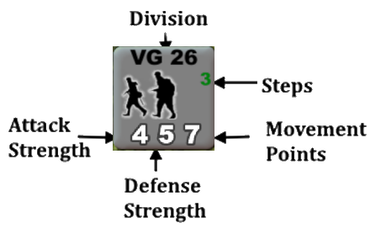

* **Attack Strength** is relative strength for combat when attacking.
* **Defense Stren**gth is relative strength for combat when defending.
* **Movement Points** is the distance the unit can move in hexes. This is affected by Terrain see TEC.
* **Steps** is the number of losses this unit can suffer in combat. Each time a unit loses a step its Attack Strength, Defense Strength and Movement Points are be affected. If a units has no more steps it is eliminated. In certain scenarios elimination of some units will cause an automatic loss for the Germans.

**3.8 Tables, Windows, Charts and Icons**

The following are used to carry out or record certain game functions.

* Computer Functions Button (**CFB**) – computer functions available to the user to display game information. This button displays when game has started on upper left area of the screen. Selecting this button will display the functions available. Selecting it again will make them disappear. Functions available are:

Select to display Game Manual;

Select to Adjust Sound;

Select for Reinforcement Display Window (RDW);

Select for Combat Results Table (CRT);

Select for Barrage Table (BT);

Select for Scenario Objectives;

Select to Display Cards in Hand;

Select to Display Keyboard Shortcuts;

Select for Terrain Effects Chart(TEC);

 Select to Save the Game;

Select to End the Game.

* Terrain Effects Chart (**TEC**) – summarizes the effects of terrain on movement, supply and combat.

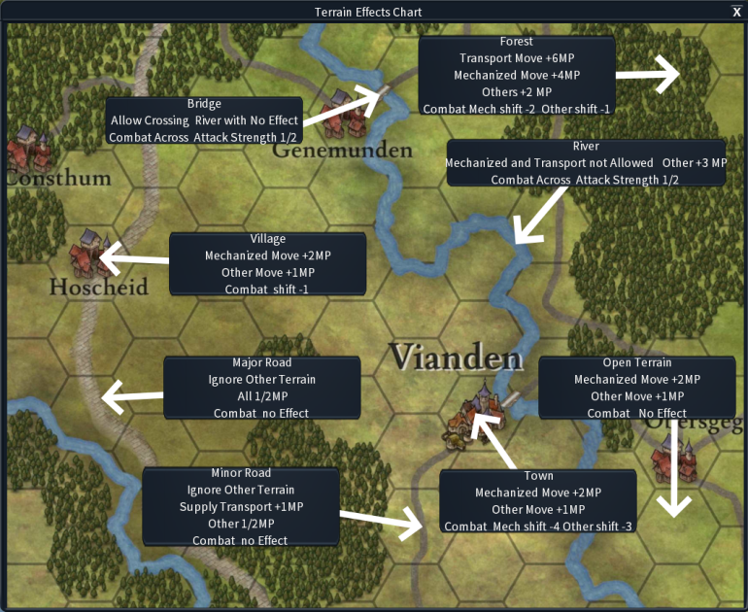

* **Combat Results Table** (**CRT**) – resolve combat.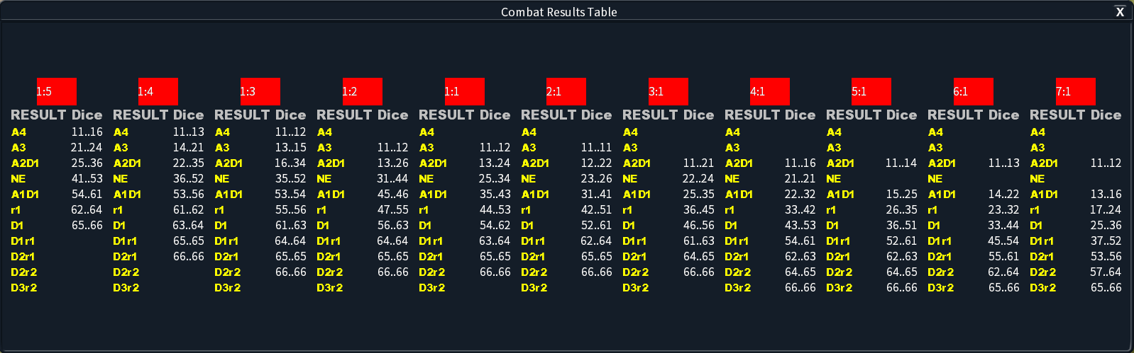

Displays Attacker to Defender Ratios for combat. For each column all 2 Dice combinations show results of battle. See Combat for explanations of results.

* **Bombardment Results Table** (**BRT**) – resolve bombardments by artillery and air power.

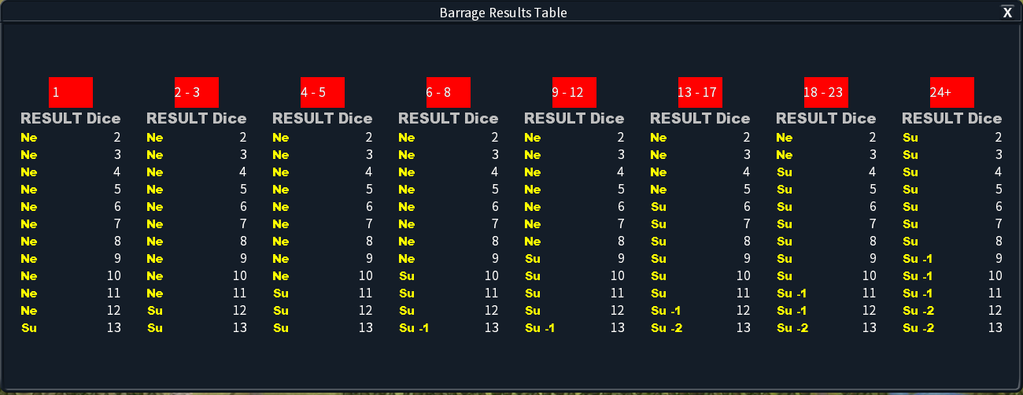

Displays Bombardment Numbers with columns of die and their results. See Bombardment for explanation of results.

* **Available Aircraft** Display (**AAD**) – airpower available to allies for that turn.

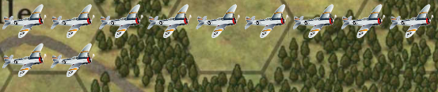Displays number of Air points available to the allies for that turn. Displayed to right of PDD.

* **Phase and Date Display** (**PDD**) – in progress phase and date.

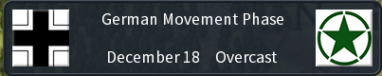

Displays current Phase, Date and Weather for the turn

* **Combat Display** – Displays Attack odds and factors affecting the combat and CRT for the specific combat. Factors affecting combat are highlighted in orange and have tooltip support. This display is automatic and disappears when Combat is complete or cancelled.

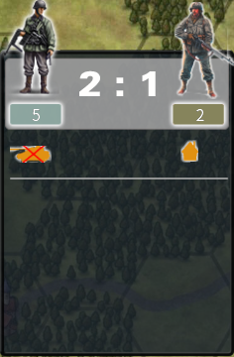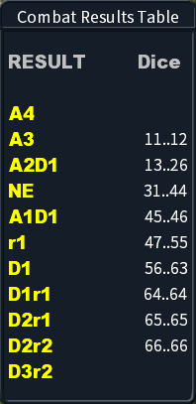

* **Combat Results Display** – Displays result of the battle. This was for MOA so attackers can continue moving. Select the display to continue.

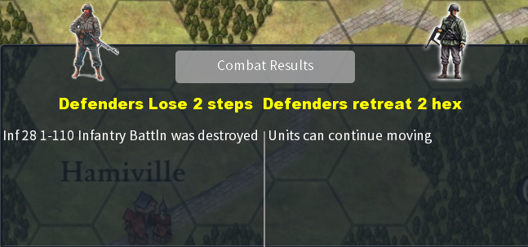

* **Overrun Unit Select** – Select Units to Participate in MOA. Select units to participate and select OK icon when complete. To cancel select outside of the window.

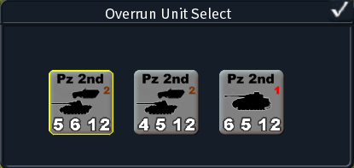

* **Select Barrage Units** – Select units to Barrage specific Hex with Bombard Target Icon. Select OK icon when complete. To cancel select outside of the window.

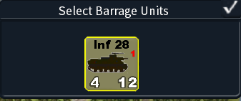

* **Barrage Display** – Displays Barrage odds and factors affecting Barrage when selecting units. This is an automatic display.

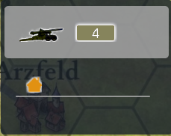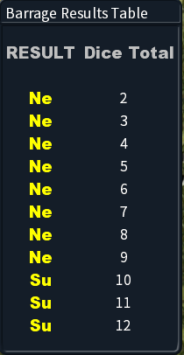

* **Reinforcement Display Window** (**RDW**) – display all reinforcement eligible for this scenario for this turn.

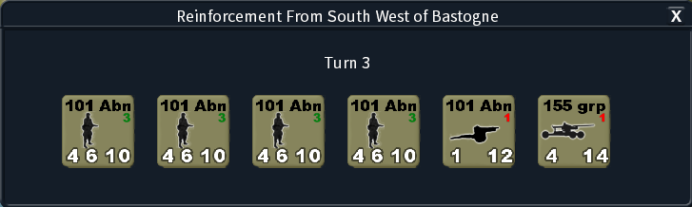

* **Next Phase Icon** Select to move game to the next phase.

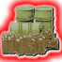

* **Supply Centre Icon** Where supply transports can access supplies



* **Exit the Board Icon** Select to exit board with unit.



* **Blown Bridge Icon S**elect to try to fix bridge.



* **Combat Possible Icon** Select to initiate combat.

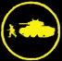

* **Mobile Assault Icon** (MOA) Select to initiate Mobile Assault.



* **Bombard Target Icon** Select to target hex for Bombard.

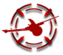

* **Bombard Selected Icon** Display Bombard target hex and select to cancel Bombard.



* **OK Icon** Select to confirm
* 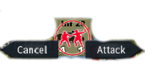**Cancel and Attack Icon** Select to initiate Attack.

**3.8 Cards**

Cards are used to affect game play. There are 5 allied cards to choose and 5 German cards. limited numbers are available to each side depending on the difficulty settings. They are played at the start of the game turn. See Cards.

**3.8.1 Allied Cards**

* 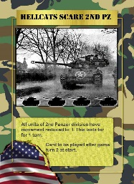**Hellcats Scare 2ND Panzer** - After playing this card all units of Second Panzer Division have their movement factor reduced to 2. This effect lasts for just 1 turn. This card is removed from the hand when played. The 2nd Panzer Division was halted by aggressive actions of the M18 Hellcats of Team Desobry of 10th Armored Division. Their ability to travel at high speed and intercept caused the Panzer Division to halt and regroup.

* 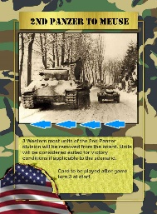**2nd Panzer to Meuse** - After playing this card the Allied or the AI must select 2 units of Second Panzer Division closest to the west to exit the map. These units are considered exited for victory conditions if applicable. This card is removed from the hand when played. This card can only be played after turn 3. The 2nd Panzer Division was on a strict schedule to cross the Meuse. It was not to be caught up in operations to clear Bastogne.
* 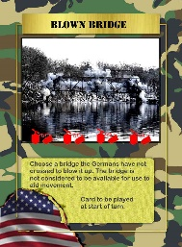**Blown Bridge** - After playing this card the American player or AI chooses one of the highlighted bridge hexes to blow. On selection the bridge is destroyed and terrain becomes riverside for that hex. This card is removed from the hand when played. Once a bridge has been chosen it cannot be blown a second time. or where it is repaired or saved by duplicity. The bridge selection only includes bridges the Germans have not crossed. There must be an Allied combat unit next to the bridge. There can be multiple cards of this type in the Allied hand.
* 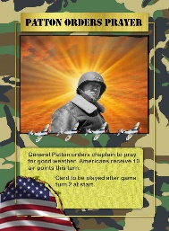**Patton Orders Prayers** - After playing this card the American player receives 10 Air Points to use that turn. The Air Points may be used as per the regular game. This card is removed from the hand when played. Playing the Card does not affect the weather for this or subsequent turns. General Patton, commander of the Third American Army, ordered his chaplain to create a prayer for good weather. "Im tired of these soldiers having to fight mud and floods as well as Germans. See if we can get God to work on our side" he said.
* 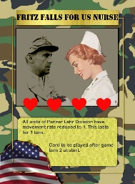**Fritz Falls for US Nurse** -After playing this card all units of Panzer Lehr Division have their movement factor reduced to 2. This effect lasts for just 1 turn. This card is removed from the hand when played. General Fritz Bayerlein, commander of the Lehr division spent the better part of a crucial day during the early stages of the Battle of the Bulge "dallying" with a beautiful American nurse that his men had captured in a field hospital. This caused paralysis in his unit for a day.
* 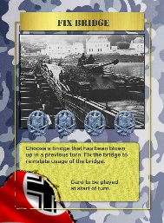

**3.8.2 German Cards**

* **Fix Bridge** - After playing this card the German player or AI chooses one of the blown bridge hexes to fix. On selection the bridge is fixed in that hex. This card is removed from the hand when played. The bridge must have been blown in a previous turn.

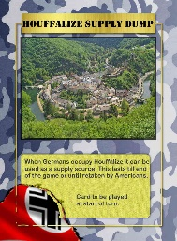

* **Houffalize Supply Dump** - After playing this card the German player can use the town of Houffalize as a supply source. This card can only be played if the Germans are in, or were the last to pass though the town. If the Americans recapture Houffalize then it ceases to be a supply dump for Germans. This card is removed from the hand when played. The Americans had created a supply dump at Houffalize to prepare for the next stage of their operations.

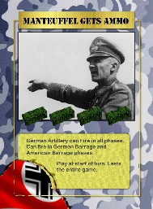

* **Manteuffel Gets Ammo** - After playing this card the German player is not restricted in usage of artillery ammunition. The Germans can now fire in both the games bombardment phases. Normal supply rules are still in effect. This effect lasts till end of the game. This card is removed from the hand when played. The German Army rationed Artillery during the actual Battle of the Bulge.
* 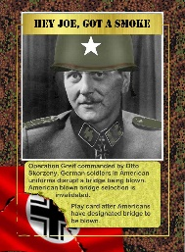**Hey Joe, got a Smoke** - After playing this card the German player invalidates any blown bridge card played by the Americans this turn. If more than 1 bridge is destroyed the German player or AI get to choose which bridge blown to invalidate. This card is removed from the hand when played. Operation Greif was a special operation commanded by Waffen-SS commando Otto Skorzeny during the Battle of the Bulge in World War II. Using German soldiers dressed in American uniforms it attempted to sabotage the destruction of bridges.
* 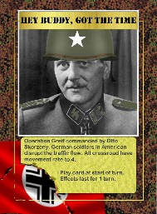**Hey Buddy got the Time** - After playing this card all crossroads for roads and paths have a movement allowance of 4 for the American player. This card is removed from the hand when played. This effect only lasts for 1 turn. Operation Greif was a special operation commanded by Waffen-SS commando Otto Skorzeny during the Battle of the Bulge in World War II. Using German soldiers dressed in American uniforms it attempted to change the road signage on the Ardennes road net.
* **3.8.3 Cards Selection**

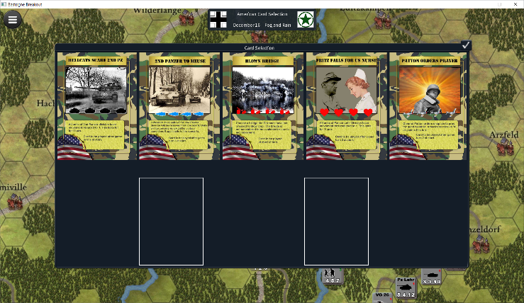Cards are selected at the start of the game by selecting a card and filling the vacant card in hand areas.

# Scenarios

All scenarios information is displayed when game is started and also when scenario objectives are selected.

* 1. **Introduction Scenario** - The Germans must control all of the Bastogne and Wiltz hexes. Six game turns.
  2. **Second Panzer goes West** – The Germans must exit all units of the Second Panzer division off of the roads on the west side of the board. They must all be in supply. Seven Game Turns.
  3. **Bastogne Breakout** – The Germans must exit all units of the Second Panzer division and elements of Panzer Lehr off of the roads on the west side of the board. They must all be in supply. Eight Game Turns. (**not available this release**)
  4. **Counterattack** – The Germans must exit all units of the Second Panzer division and elements of Panzer Lehr off of the roads on the west side of the board. They must all be in supply. Nine Game Turns. (**not available this release**)

# Sequence Of Play

At the start of the game the German player selects which cards they will use for the game. The Allied player then selects their card. The number of cards per side is determined by Scenario and Difficulty. The game now begins.

The game is played in game turns representing one day of the battle. The German player starts, completes their sequence and is followed by the Allied player. Each turn is composed of a number of phases which must be completed before the next phase can begin. Certain phase require the other player to have control. This continues until maximum number of turns for that scenario is reached. The winner is the determined.

**5.1** **Game Phases**

**Allied Card** – The Allied Player now can play any and all cards in their hand which available for this turn.

**German Card** – The German Player now can play any and all cards in their hand which available for this turn.

**German Roll for Bridge Repair** – If the German player can now attempt to repair a Blown Bridge by rolling dice on BRT. Only one bridge can be repaired per turn. If more than 1 bridge has been blown the Germans can left click on bridge they wish to repair.

**German Limber Artillery** – The German Player now can change status of their artillery counters to limbered or unlimbered. Regular artillery must be limbered to move and unlimbered to bombard. For mobile artillery limbering and unlimbering changes movement and bombardment efficiencies. All German counters are shaded at the start of this phase. All eligible for limber/unlimber will be unshaded.

**German Movement** – The German Player now can move all eligible units. All German counters are shaded at the start of this phase. All eligible for movement will be unshaded. Left click on eligible units to show which hexes it can move to. See the Movement rules. Movement can include Mobile Assault (**MA**) attacks as part of movement. See the Combat section.

**Allied Defensive Barrage** – The Allied Player now target all in range German Units that can be bombarded. A bombard selection icon will be overlaid on eligible German units to be bombarded.

**German Offensive Barrage** – The German Player can now target in range allied units. See above.

**German Barrage Resolve -** The Computer will now animate all of the targeted bombardments. See the Bombard section.

**German Combat** – The German Player can now attack all eligible Allied units. These units will be identified by the attack icon. Left click on the icon to start the Attack. See Combat section.

**German Exploitation** – Any German motorized units that did not participate in movement or combat this turn are now eligible for movement. This can include Mobile Assault attacks as well.

**German Supply** – The German player attempts to provide supply for all of their units. See Supply.

**Allied Reinforcements**  – The computer displays the RDW for that turn for the Allies. See Reinforcement section.

**Allied Movement** – Same as German Movement except for Allied units.

**German Barrage Defend**  – Same as Allied Defensive Barrage German except for Allied units.

**Allied Offensive Barrage** – The Allied Player can now target in range German units. See above.

**Allied Barrage Resolve -** The Computer will now animate all of the targeted bombardments. See the Bombard section.

**Allied Combat** – The Allied Player can now attack all eligible German units. These units will be identified by the attack icon. Left click on the icon to start the Attack. See Combat section.

**Allied Exploitation** – Any Allied motorized units that did not participate in movement or combat this turn are now eligible for movement. This can include Mobile Assault attacks as well.

**Allied Supply** – The Computer automatically determines which allied units are in supply.

**Allied Supply** – The Computer automatically determines which allied units are in supply.

**End Game Turn** – The Computer checks to see if end of game and if it is determines the winner. If not end of game the computer will advance turn by 1, roll dice for weather and roll dice for Air Support

# Movement

Counters are moved one at a time from the hex they are occupying trough a path of adjacent hexes on the map hex grid. Each hex grid incurs movement points that are subtracted from its Movement Points for. The points are dependent on the terrain type in the hex (see TEC). Once the MP is at zero the counter can move no further. If it enters an enemy controlled hex it may make an Mobile Assault(MOA). If successful it may continue moving.

When the chosen counter is left clicked the computer will highlight the chosen counter and highlight all possible hexes that the counter can reach as well as MOA’s possible.

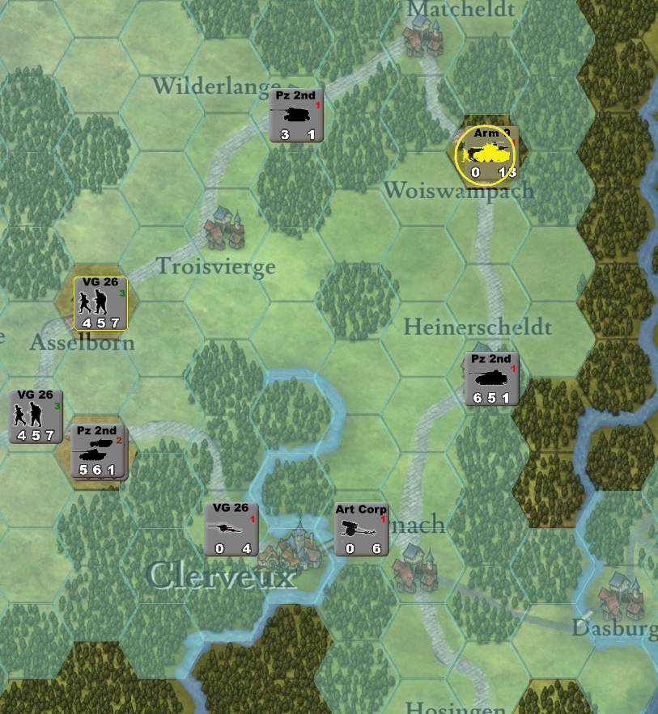

The user left clicks on the move-to hex to initiate move. To cancel move left click on a hex which has not been highlighted. To start a MOA left click on the MOA symbol.

**6.1 Movement Limitations**

* **Unused Movement Points** cannot be saved for later in the movement phase or for subsequent turns. It cannot be transferred to other counters.
* **Movement End** once the highlighted hex for possible moves has been selected, the computer will automatically move the counter and move is considered over for the counter. It cannot be undone.
* **Combat** occur as part of movement see MOA in combat section.

**6.2 Effects of Terrain on Movement**

The basic per hex movement point is 1 MP per hex. Certain hexes and crossing certain hex sides may cost extra. Costs are cumulative .This is described in the TEC and below:

* **Hex sides** – rivers block mechanized units and artillery from crossing if there is not a bridge present. Infantry cost is +3 MP. Major and minors roads must cross a hex side to lower the MP cost for movement between hexes. MP is ½ for both except it is 1 for Supply transports on minor roads.
* **Combat -**occurs as part of movement when a counter tries to enter a hex containing an enemy unit. See MOA in combat section. The cost for entering a enemy hex is +3 MP. After successful completion of the combat the counter can continue moving. If the unit stated its move in a ZOC it cannot do a MOA. In that case the move is over.
* **ZOC** –The six hexes that surround a combat unit are the zone of control for that unit. ZOC does not extend across non-bridge river hex sides.
  + Towed artillery does not exert a ZOC.
  + It costs +2 MP to enter a ZOC.
  + Units that start their turn in a ZOC cannot make a MOA in their turn.
  + Transport unit cannot enter a ZOC unless there is German unit occupying it.

**6.3 Movement and Friendly Units**

Units may move freely through hexes that contain other units with the following exceptions:

* **Major Roads** – if there are greater than 4 steps occupying the hex add +3 MP, if greater than 2 add +1MP.
* **Minor Roads** – if there are greater than 4 steps occupying the hex add +3 MP, if greater than 2 add +2MP.

**6.4 Reinforcements entering the board.**

Only the allied side has reinforcements and they enter the board on specific locations and specific turn see the **RDW**. Reinforcements can move in that turn. If the location is occupied by a German unit then the reinforcements can only be placed in adjacent hexes and they cannot move that turn.

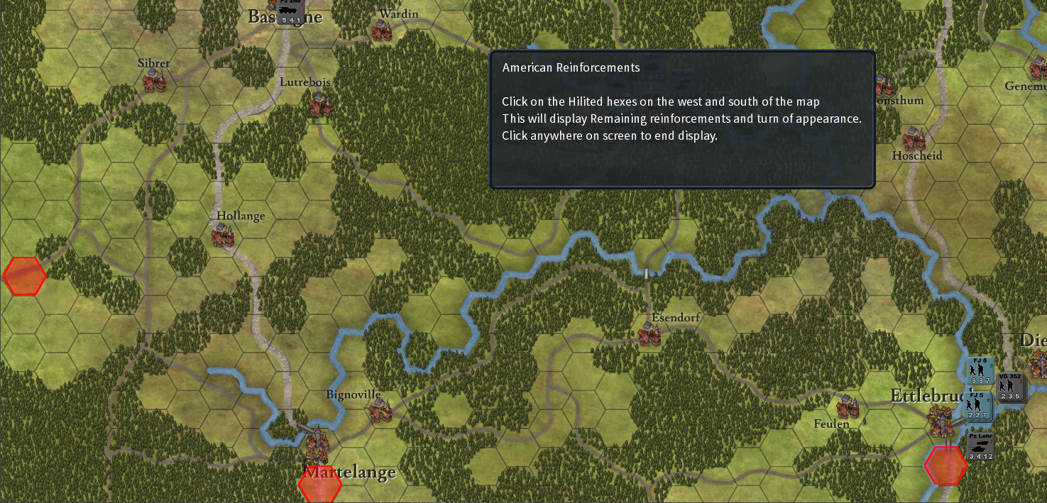

Hexes hilted in red are the reinforcement entry hexes.

**6.5 Exiting the board.**

TBA

# Combat

Combat is voluntary and the phasing player decides which hex to attack. At the start of the combat phase all possible combats will have the Combat Possible Icon displayed on hexes that can be attacked.

Within the constraints of this phase, the attacker determines which units are involved in each combat, and the order in which combats are resolved. All combats must be resolved during that combat phase.

**7.1 Combat Procedure**

* 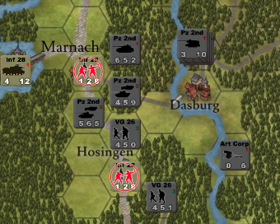Select the hex to be attacked by selecting icon on that hex.
* All eligible attackers will now be unshaded in the adjacent hexes. The combat display will now be show to reflect the odds for the combat.

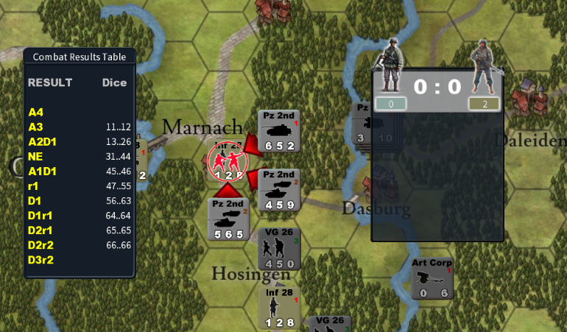

* Select the attackers.
* Selecting the attackers will update the combat display and show the Cancel and Attack Icons.
* To complete the attack, select the Attack Icon.

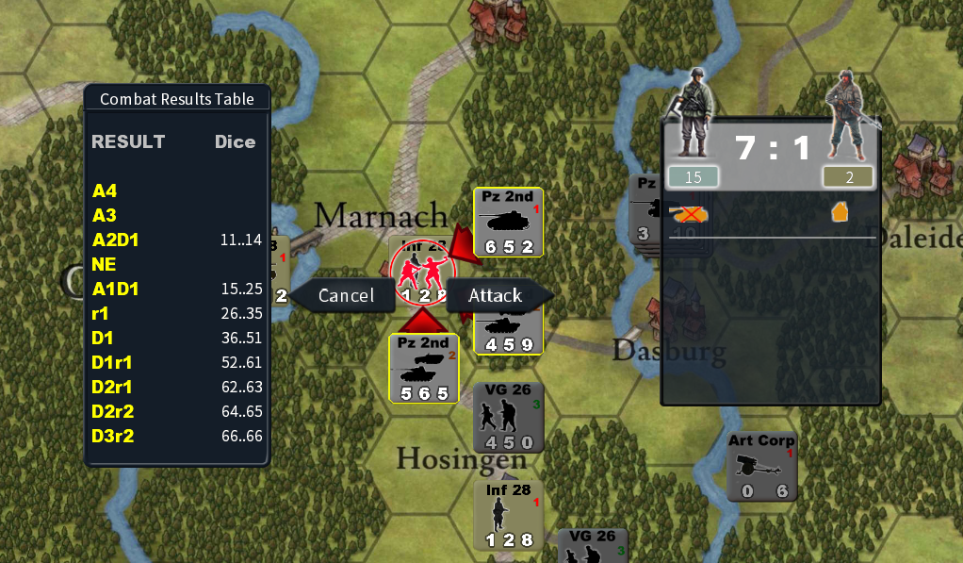

* Computer will roll the dice and resolve the combat and retreat defender if necessary.
* The Combat Result Display will be shown. Select the display to end the Combat.

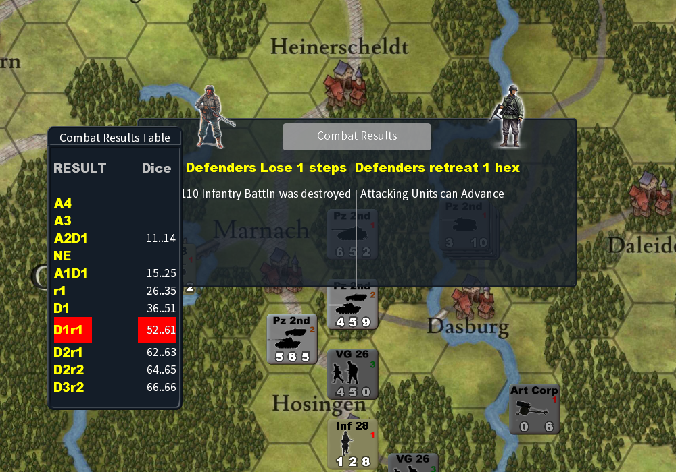

* If attacker can advance then all units will be shaded except for attacking units that can advance. Select units to advance.
* Attack can be cancelled by selecting a part of the map not involved in the combat.
* Advance after combat can be cancelled by selecting part of map not involved in combat.
* If ist a Mobile Assault(MOA) the unit can continue moving.
  1. **Which Units Involved**

* All units in a hex must be attacked.
* The attacker determines which units are attacking by selecting unit. A right click will be required to bring units to the front that are in a stack so they can be selected.
* A hex can only be attacked once per phase.
* Units can only attack once per phase.
  1. **Calculating the Odds**

All units involved in a combat must contribute their entire strength to that combat. Modify combat strengths as needed for specific terrain effects before calculating the odds. Total the modified combat strengths of all attackers into the attacker total, and the combat strengths of all defenders into the defender total. Divide the attacker total to get the defender total. Express the result as a ratio, then simplify the result to one of the odds ratios on the CRT. Shift the odds ratios to the left or right on the table to reflect other conditions.

* **Rounding Odds** – Odds are always rounded in favor of the defender.
* **Maximum and Minimum** – Odds executed greater than 7 to 1 are treated as 7 to 1. Odds shifted less than 1 to 5 are treated as 1 to 5. Odds before shift less than 1 to 5 are not allowed.

* 1. **Terrain Effects on Combat**

Certain types of terrain multiply or divide a unit’s combat strength; see the TEC for details. Apply the modification to the unit’s current printed combat strength or Odds ratio. All modifications are cumulative.

* Half unit strength that attacks across Bridges.
* Quarter unit strength for Mechanized units attacking across River. All others half.
* If attacking total units are more than half mechanized and they are attacking Forest, a Village or Town shift the ratio table to the left by 1.
* If attacking a Town shift left by 3.
* If attacking Forest shift left by 1.
* If attacking Village shift left by 1.
  1. **Combat Die Roll**

When OK Icon is selected the computer will select the odds ratio to use and roll the die. The Combat Result will be determined by checking the die roll on the CRT.

* 1. **Combat Results**

Results are Capitol letter either “A” or “D” followed by the number of steps to lose. If “A” the attacker must lose the steps. If “D” the defender must lose the steps. This can be followed by an “r” for retreat and a number of hexes to retreat. Example:

* A2D1 – the attacker loses 2 steps and the defender loses 1 step.
* D1r1 – the attacker loses a step and must retreat 1 hex.

**7.7 Combat Results Application**

If attacker or defender needs to take one or more of a step loss the units with the greatest number of steps will be chosen to take the loss. If a unit can not take anymore steps it is eliminated.

* 1. **Retreat Application**

Retreats will be calculated to take unit to closest supply source avoiding Zones of Control.

* 1. **Advance**

If the attacked hex has been vacated because of combat all attacking units can be advanced into vacated hex. All phasing players will be shaded except for those that can advance. Select a unit and all hexes that it can advance to will be highlighted. Select a highlighted hex to advance there for that unit. To end or cancel advances select a hex on the board not involved in the combat.

* 1. **Mobile Assault**

Mobile Assault is handled the same as combat except the attacking units can keep moving if the hex is vacated. For MOA attackers must be in same hex.

# Bombardment

Artillery Units that have an attack factor greater than zero(unlimbered for towed artillery) may now designate hexes to bombard. Aircraft if available for the allied player can also be used to bombard with an attack factor of 5 for each.

**8.1 Bombardment Procedure**

* Select the hex with Bombard Target icon on that hex to bombard the units in that hex.

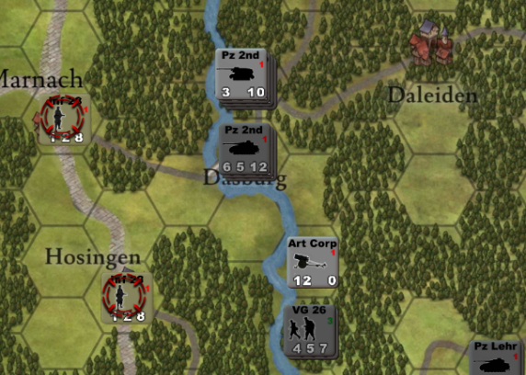

* All eligible units that can bombard the hex will be displayed in the Select Barrage Units window.

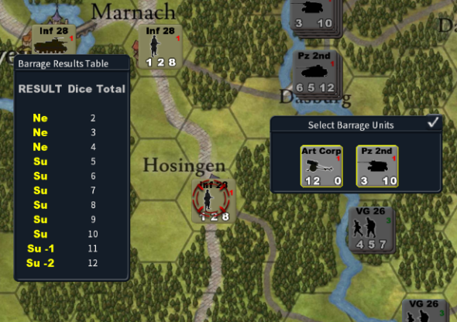

* The Barrage Display window will be shown automatically. In this case both units have been chosen for a total of 15 barrage points. Factors affecting the barrage are also displayed. In this case bombardment hex is in town.

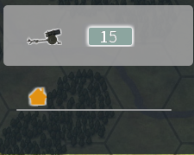

* Select units to participate and Select OK Icon when complete or select part of map not involved with bombardment to cancel.
* 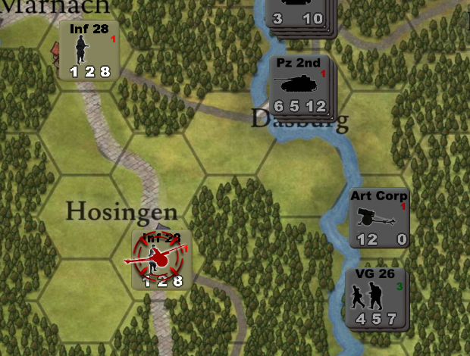The Bombard Icon will be replaced by the Bombard Selected Icon.
* To cancel Bombard Selected select it.
  1. **Bombardment Ranges**

All Artillery have a range of 3 hexes not including the hex they are occupying except for NebWerfer brigades and the 155 mm Regiment which have a range of 4.

* 1. **Bombardment Effects**

Bombardment effects are applied immediately and last till the Supply Phase for that unit..

* **NE** – No effect.
* **SU** – Suppressed.
  + Attack Factor set to zero,
  + Movement Factor set to half,
  + Defense Factor set to half,
  + Unit does not have ZOC.
* **SU1** -Suppressed and lose 1 step.
* **SU2** – Suppresses and lose 2 steps.
  1. **German Bombardment Restrictions**

Unless the Manteuffel gets Ammo card has been played the Germans units can only bombard in 1 phase per Turn.

# Supply

When units move or have combat, they use their Movement Points and Attack/Defense Strengths. Attack is reduced to ¼ and Defense to ½ if they are involved in any combat. To replenish the value the units must be in supply in their respective supply phase. The Allied supply phase is handled by the computer.

* 1. **German Supply Procedure**
* 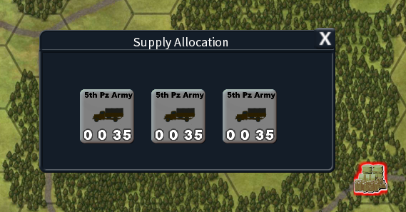At the start of the German Supply Phase the user is presented with the Supply Allocation Window. All the Supply Centre Icons are display on the map including Houffalize if it’s available. All transports have a Movement Allowance of 35.
* 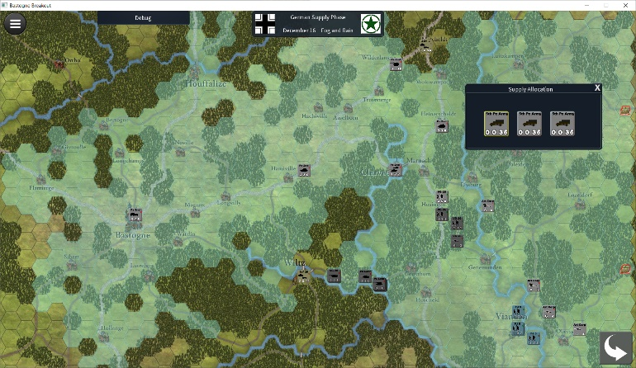Selection of a transport will Highlight all hexes the transport can travel to and the cursor will become a German Icon. The Icon can be hovered to reveal where the transport can be moved to and which units will be supplied. Units within 10 MP of transport placement can be supplied. Units that can be supplied will become unshaded.
* After selection of the hex the transport will be moved to the hex and all units within 10 MP of the transport will be supplied.
* The other transports can then be selected in order to try to bring all other units in supply.
* If Mechanized units if not supplied it will be given 1 Movement Point in its respective supply phase. Infantry units will be given 3. Attack and Defense are left at 1 point.

# Allied Order of Battle

* 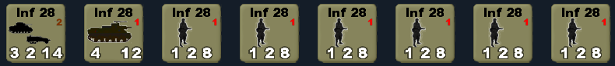**28th Infantry Division "Keystone**

707 Tank battalion turn1 and Divisional Artillery,

109 Regiment 3 battalions,

110 Regiment 3 battalions, 707 tank battalion **at start**.

* 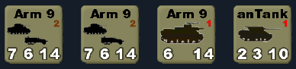**9th Armor Division "Phantom”**
* CCA, and CCR Combat Commands,
* Divisional Artillery turn st start.
* 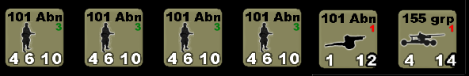**101st Airborne Division**

501st,502nd and 503th Airborne Regiments, 327 Glider Regiment, Divisional Artillery and 155mm Artillery Group **turn 3**.

* 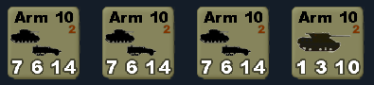**10th Armor Division "Red Diamond**”
* CCA, CCB and CCR Combat Commands,
* 609 Tank Destroyer battalion turn 3.
* 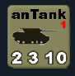**607th Tank Destroyer Battalion turn 5**
* 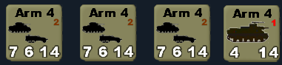**4th Armor Division**
* CCA, CCB and CCR Combat Commands,
* Divisional Artillery **turn 7**.
* 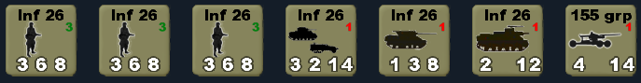**26th Infantry Division "Yankee”**
* 101st, 104th, and 328th Infantry Regiments,
* Divisional Artillery turn 7 and 155mm Artillery group,
* 725 Armor Battalion and 818 Tank Destroyer Battalion **turn 7**.
* 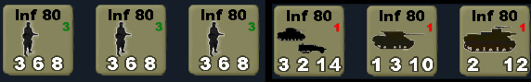**80th Infantry Division "Blue Ridge”**
* 317th, 318th, and 319th Infantry Regiments,
* Divisional Artillery turn 7 and 702nd Armor Battalion ,
* 610 Tank Destroyer Battalion **turn 7**.

# German Order of Battle

* **276th Volksgrenadier Division**

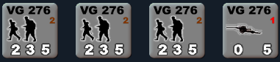

* 316th, 320th and 423rd Volksgrenadier Regiments,
* 276th Artillery Regiment **at start**.
* **352 Volksgrenadier Division**

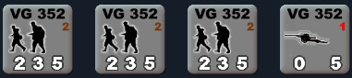

* 914th, 915th and 916th Volksgrenadier Regiments,
* 352nd Artillery Regiment **at start**.
* **5th Fallschirmjäger Division**

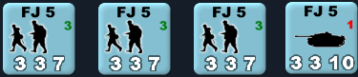

* 13th, 14th and 15th Parachute Infantry Regiments916th Volksgrenadier Regiments,
* 11th Assault Gun Brigade **at start**.
* **26th Volksgrenadier Division**

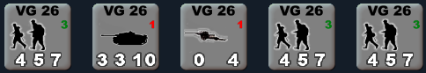

* 39th Fusilier and 77th and 78th Volksgrenadier Regiments,
* 26th Anti Tank Battalion,
* 26th Artillery Regiment **at start**.
* **XLVII Panzer Corps Artillery**

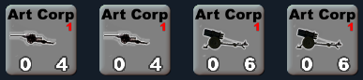

* 9th and 17th Volkswerfer Brigade,
* 766th Volksartillirie Corps **at start.**
* 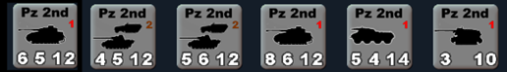**2Nd Panzer Division**
* Kampgruppe von Cochmann, Gutmann-a, Gutmann-b, von Bohm,
* 2nd Recon Battalion,
* Divisional Artillery **at start.**
* 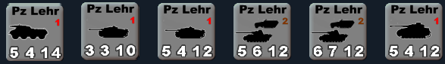**Panzer Lehr Division**
* Kampgruppe Kunkel, von Fallois, 901 and 902,
* 130d Recon Battalion,
* Divisional Artillery **at start.**